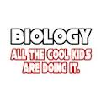
GETTING TO KNOW YOU

Do you prefer to be called something else (nickname, middle name, etc.)?

List a few of your favorite things: (movie, bands, activities, food, sports, etc)

Tell me something you are good at or something you enjoy doing.

What do you feel is your biggest weakness or struggle in the classroom?

What is one way that you can overcome or improve this weakness?

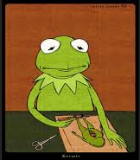
What is your goal for this class that you would like to achieve by the end of the year?

