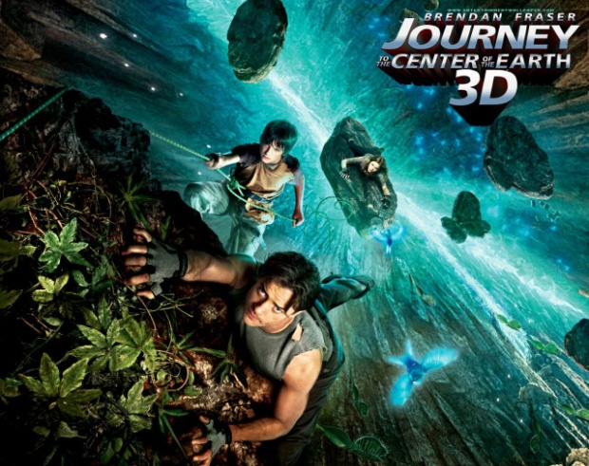
Journey to the Center of the Earth

For this creative, yet scientific, writing assignment, you will be narrating a story of your journey to the center of the earth. Obviously, this story in not realistic, as we know the center of the earth is over 6,000 kilometers in depth and over 5,000 degrees Celsius, so this is more of an action-fantasy story intertwined with accurate descriptions of the earth’s layers! You must give detailed descriptions of each of the layers of the earth, and describe some events that happened or obstacles you faced along the way. I will be grading according to the rubric below, so please use it as you complete this assignment.

Objectives:
- Produce clear and coherent writing, with accurate grammar, spelling, and sentence structure
- Explain the various layers of the Earth’s interior, providing details of the characteristics unique to that layer

“Journey to the Center of the Earth” Rubric

Journey to the Center of the Earth | 1 point | 3 points | 5 points
Sources | 1 of the criteria is represented | 2 of the criteria are represented | Reliable, relevant, and scientific sources used  At least 2 sources cited in the works cited page  Use of APA style citations
Paper Format | 1 of the criteria is represented | 2 of the criteria are represented | Creative, first-person 1-2 page double-spaced narrative  Proper spelling and grammar  11/12 point font (Calibri, Arial, Times New Roman)
Crust | 1 of the criteria is represented | 2 of the criteria are represented | Explanation of how you got into the crust (drill, etc.) Does NOT need to be 100% realistic  Did you pass through continental or oceanic crust to get to the mantle?  Description of journey through crust, including characteristics from notes
Mantle | 1 of the criteria is represented | 2 of the criteria are represented | Description of what happened as you came upon the Moho boundary  Description of how the mantle changed as you passed through it (temp., state of matter, pressure, etc.)  Proper use of the words: lithosphere, asthenosphere, upper and lower mantle, Mohorovicic discontinuity
Core | 1 of the criteria is represented | 2 of the criteria are represented | Differentiate between the inner and outer core  Description of the composition, temperature, density, etc. of the outer and inner core  Explain an obstacle that you had to overcome within the core (magnetism, extreme heat, dense heavy metals, etc.)

Total Points Possible = 25

