Topographic Maps Worksheet Name _______________________
This pre-lab activity was designed by the ICC Earth Science Department, and you will use their website to complete this worksheet. Place the answers to the questions listed below on this sheet as you go through the website.
http://faculty.icc.edu/easc111lab/labs/labe/pre_labe.htm
1.) List the information you found on the road map and the topographic map. (map images located in Lab E webpage)
Road Map | Topographic Map

2.) What is the elevation of Humphreys Peak? _________________ feet (link for topographic map in Lab E webpage)

3.) Label the contours directly on the map below. Define the words below using your own words:
Contour lines-

Relief-

Elevation-
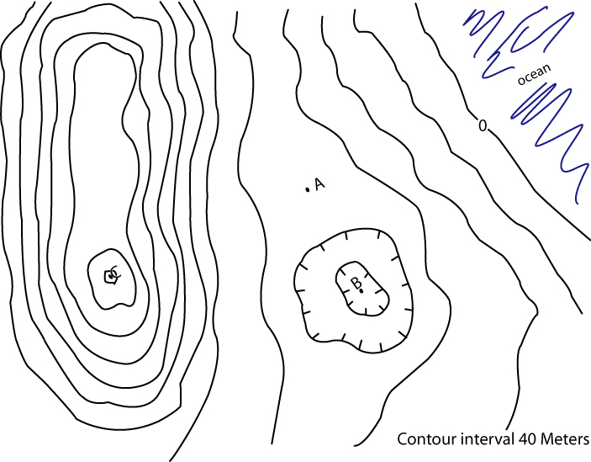
4.) Total relief of the map: _____________________________ meters.
5.) Point A must lie at an elevation higher than _____ meters but lower than _____ meters.
6.) Point B must lie at an elevation higher than _____ meters but lower than _____ meters.
7.) Place an X on the map in the area with the steepest slope. Place a Y on the map where
the flattest part of the land is. Explain why you chose those locations to label "X" and "Y".

